**Sergio Irianda**

**CS 330**

**Proposal for Project 1**

**1.**

For this project, I have selected a 2D image of a round table with different objects placed on it. The image consists of the following:

1. A Starbucks coffee cup
2. A wallet
3. An open laptop (centered)
4. A rectangular box earbud holder

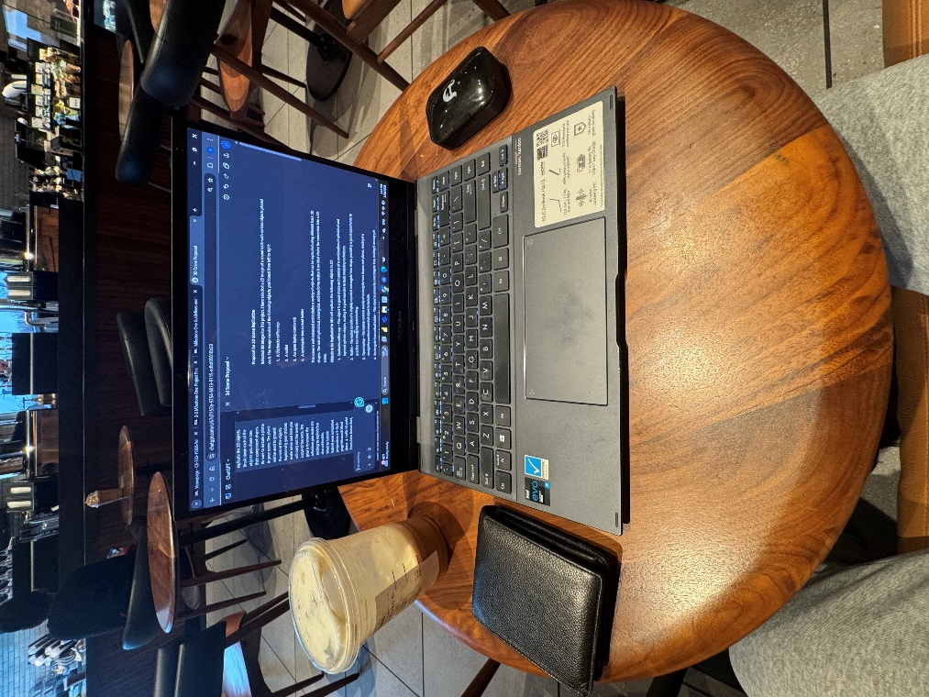

**2.**

I will replicate the following objects in 3D:

1. Starbucks coffee cup – This object is a good choice since it has a cylindrical shape and round lid to add a torus.
2. Wallet – The wallet consists of a slightly rounded rectangular box shape, providing a good opportunity to practice box modeling and detailing.
3. Open laptop – The laptop consists mainly of rectangular box shapes and planes, making it straightforward but good practice.
4. Rectangular box earbud holder – This object is primarily a rectangular box.

**3.**

I will use the following basic 3D shapes:

1. **Box** – Used for the laptop body, screen, wallet, and the earbud holder.
2. **Cylinder** – Used for the Starbucks coffee cup’s main body.
3. **Toris** – Used for the coffee cup’s lid
4. **Plane** – Used to create the tabletop, grounding all the objects within the scene.